Interfacing 0.96 Inch OLED I2C Display with STM32

By Muhtadina Serniabat Tasin | 2232160642

Course: CSE331L.8
Instructor: Ahmed Kiser
Faculty: SKH1

Semester: Spring 2026
North South University

1. Introduction

The 0.96 inch OLED I2C display is a widely used output device in embedded systems for displaying text, graphics, and sensor data. It is based on the SSD1306 controller, offering a resolution of 128×64 pixels with low power consumption and high contrast. (Datasheet Hub)
This display is commonly used in microcontroller-based systems such as STM32 due to its simplicity and minimal pin requirements using the I2C protocol.

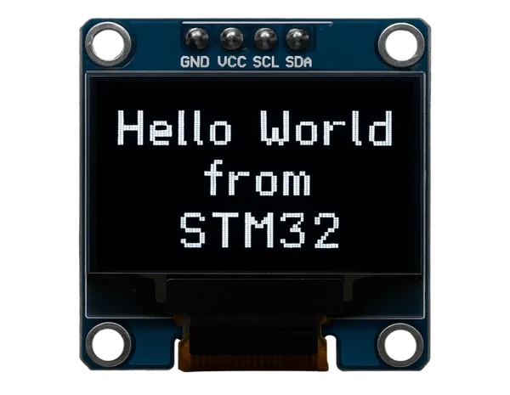

2. Description of the Device & Working Principle

2.1 Device Description
The OLED (Organic Light Emitting Diode) display consists of self-emitting pixels, meaning each pixel generates its own light. Unlike LCDs, it does not require a backlight, resulting in:
- Higher contrast
- Better visibility in dark environments
- Lower power consumption
Typical specifications:
- Size: 0.96 inch
- Resolution: 128 × 64 pixels
- Driver IC: SSD1306
- Communication: I2C / SPI
- Operating Voltage: 3.3V–5V

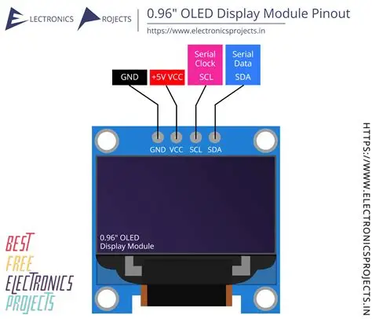

2.2 Working Principle
The display operates using the I2C communication protocol, which uses only two signal lines:
- SDA (Serial Data) – transfers data
- SCL (Serial Clock) – synchronizes data transmission
The STM32 sends commands and pixel data to the SSD1306 controller. The controller stores this data in its internal buffer and drives the OLED pixels accordingly.
Each pixel lights up when current passes through the organic material, producing visible light.

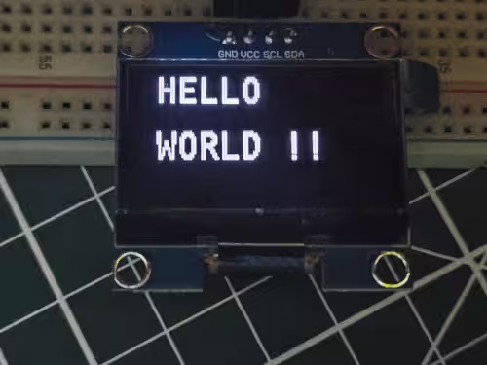

3. Pin Diagram and Description

3.1 Pin Configuration (I2C Version)
Pin Name | Description
VCC | Power supply (3.3V or 5V)
GND | Ground
SDA | Serial Data line (I2C)
SCL | Serial Clock line (I2C)



4. Interfacing with STM32

4.1 Hardware Connection
OLED Pin | STM32 Connection
VCC | 3.3V
GND | GND
SDA | I2C SDA (e.g., PB7)
SCL | I2C SCL (e.g., PB6)
- STM32 uses I2C peripheral (I2C1)
- Typical configuration:
  - PB6 → SCL
  - PB7 → SDA
- I2C clock speed: 100 kHz or 400 kHz
- OLED I2C address: usually 0x3C

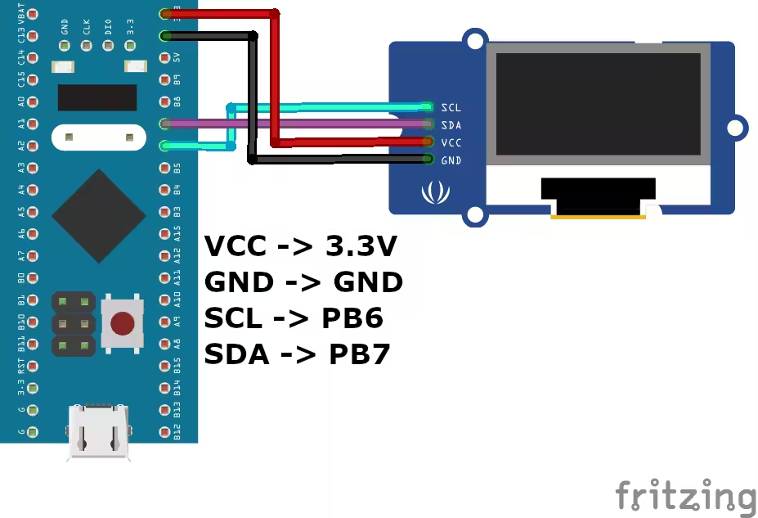

5. Sample C Code (STM32 HAL)

#include "stm32f1xx_hal.h"
#include "ssd1306.h"
#include "fonts.h"

I2C_HandleTypeDef hi2c1;

int main(void)
{
HAL_Init();
SystemClock_Config();

MX_I2C1_Init();

SSD1306_Init();
SSD1306_GotoXY(10,10);
SSD1306_Puts("Hello STM32", &Font_7x10, 1);
SSD1306_UpdateScreen();

while (1)
{
}
}

void MX_I2C1_Init(void)
{
hi2c1.Instance = I2C1;
hi2c1.Init.ClockSpeed = 400000;
hi2c1.Init.DutyCycle = I2C_DUTYCYCLE_2;
hi2c1.Init.AddressingMode = I2C_ADDRESSINGMODE_7BIT;
HAL_I2C_Init(&hi2c1);
}

- SSD1306_Init() → initializes display
- SSD1306_Puts() → writes text
- SSD1306_UpdateScreen() → refreshes display

7. Applications
- Sensor data display
- Embedded dashboards
- IoT devices
- Wearable electronics

8. Conclusion
The 0.96 inch OLED I2C display is an efficient and compact display solution for STM32-based embedded systems. Its simple I2C interface reduces wiring complexity while providing high-quality visual output. Proper configuration of the I2C peripheral and correct addressing ensures reliable communication between STM32 and the display.

9. Article Reference
- STM32 SSD1306 OLED I2C Tutorial
- https://controllerstech.com/oled-display-using-i2c-stm32/

10. Tutorial Reference
0.96 inch OLED SSD1306 Complete Guide

